**Voice-Activated Assistant**

**Introduction :-**

Alexa is a voice-activated assistant that takes user voice input, processes the text, and provides responses in both text and speech formats. This project leverages speech recognition, text processing, and text-to-speech conversion to create an interactive experience.

**Project Structure :-**

The project is divided into three main parts:

1. **Voice Input to Text Conversion:** Captures user voice input and converts it to text.
2. **Text Processing:** Analyzes the text to generate appropriate responses.
3. **Text to Voice Output:** Converts the response text back to speech.

**Detailed Code Explanation :-**

**Importing Required Libraries :-**

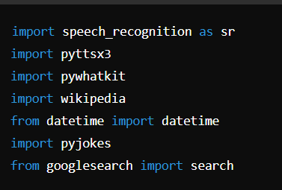

**Welcome Message :-**

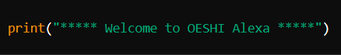

**Text to Speech Function :-**

This function uses **pyttsx3** to convert text responses into speech.

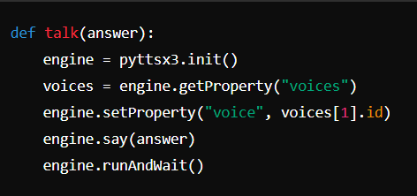

**Processing User Queries :-**

The function **processQuestion** handles different types of queries and provides appropriate responses.

def processQuestion(question):

if "what are you doing" in question:

print("I am waiting for your queries")

talk("I am waiting for your queries")

return True

elif "how are you" in question:

print("I am good, what about you? and thanks for asking")

talk("I am good, what about you? and thanks for asking")

return True

elif "play" in question:

question = question.replace("play", "")

pywhatkit.playonyt(question)

return True

elif "who is" or "about" in question:

question = question.replace("about", "")

print(wikipedia.summary(question, 1))

talk(wikipedia.summary(question, 1))

return True

elif "time" in question:

time = datetime.today().time().strftime("%I:%M %p")

date = datetime.today().strftime("%Y-%m-%d")

day = datetime.today().strftime("%A")

print("Current time:", time)

print("Current Date:", date)

print("Day:", day)

talk(time)

talk(date)

talk(day)

return True

elif "funny jokes" in question:

joke = pyjokes.get_joke()

print(joke)

talk(joke)

return True

elif "love you" in question:

talk("Sorry, I have a boyfriend. His name is Vishnu")

return True

elif "open website" in question:

GoogleSearch = GoogleSearch().search("something")

return True

elif "bye" or "goodnight" in question:

talk("Okay, bye. Please take care. Will meet you again later")

return False

else:

print("Sorry, I didn't recognize your queries. Thanks for asking")

return True

**Capturing User Questions :-**

The function **getQuestion** listens for the user's voice input and converts it to text using the Google Speech Recognition API.

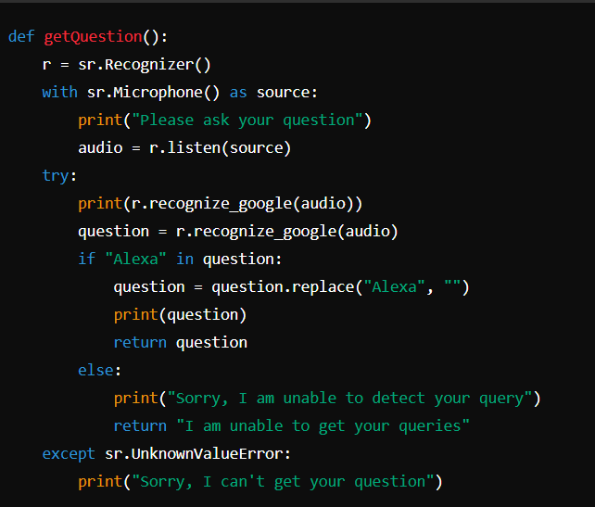

**Main Execution Loop :-**

The program continuously listens for user input and processes questions until the user decides to exit.

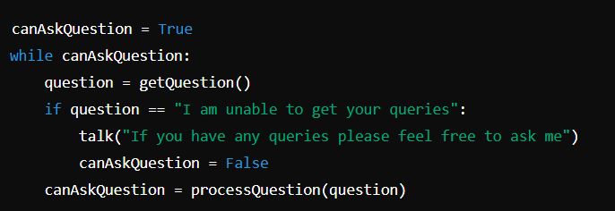

**Conclusion**

This document provides a detailed overview of the OESHI Alexa project. The code captures voice input, processes it to generate relevant responses, and converts those responses back to speech, creating an interactive voice-activated assistant. This project can be further enhanced by adding more functionalities and improving the speech recognition and processing capabilities.